Individually Floating Rechargeable Electric Shaver
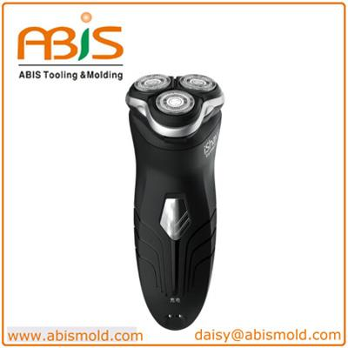 | 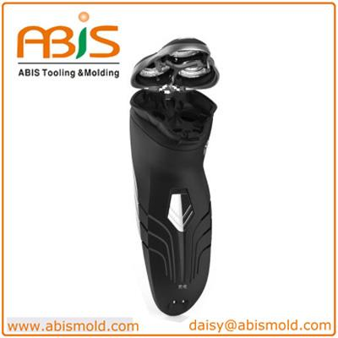
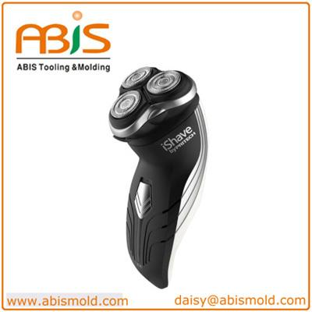 | 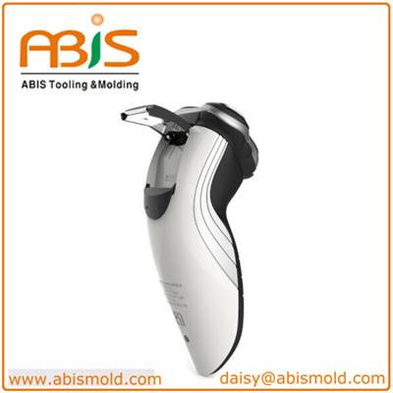
ABIS Mold was found in 1996 in Shenzhen, adjacent to HK, China. and we moved to Long gang District in 2010.With the advanced facilities from Germany, Switzerland and Japan, and a highly experienced design and engineering team. Our molding press machine ranges from 40T to 650T, 300+ molds capacity each year, and 70 % are exported to Europe and North America. 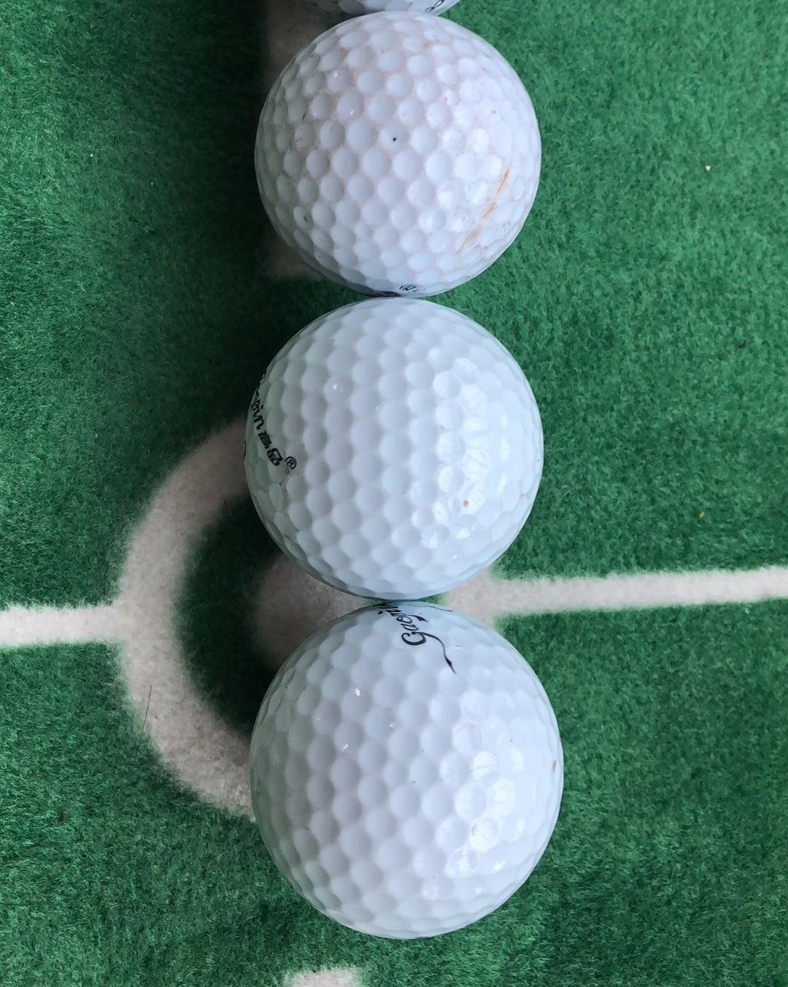
In addition to our plastic mold and molding specialties, we also can provide you the services such us die casting, stamping /punching, blowing mold, as well as the secondary process.

Product Description
Part Name | ​Individually Floating Rechargeable Electric Shaver
Description | Man Shaver
Country of Original | China (ShenZhen)
Current Export Markets | North America
Lead Time | 30 Days

Key Specification
Pop-up trimmer
With On/Off switch
3-head rechargeable shaver
Comfortable and perfect shaving
Triple heads individually floating
Cord charge with charging indicator
Accessories: Cleaning brush and charging cord

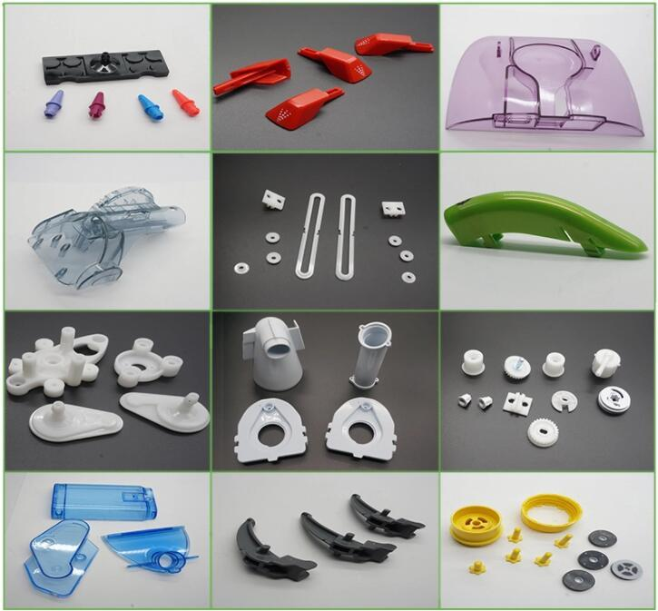
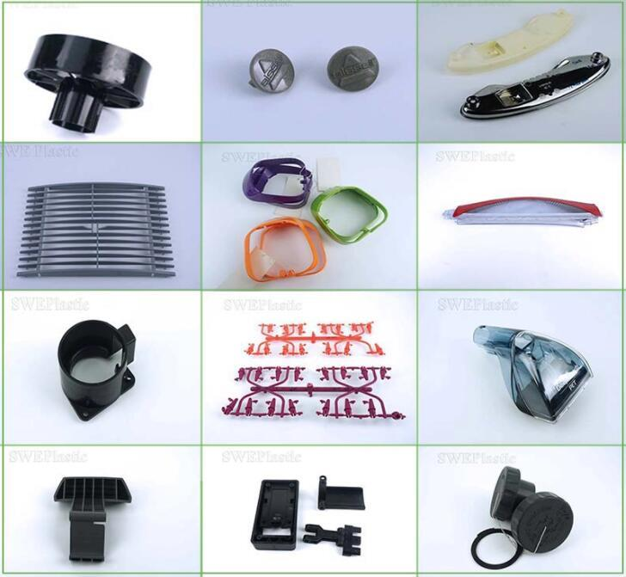
Project Procedure

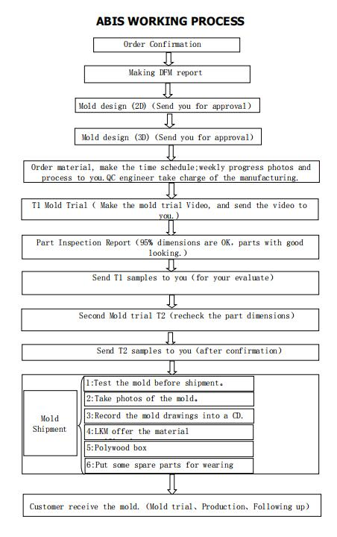

Payment Terms
1. T/T: 40% Deposit,30% upon T1 Sample,30% Balance before shipment
2. L/C: irrevocable 100% L/C at sight.
Workshop
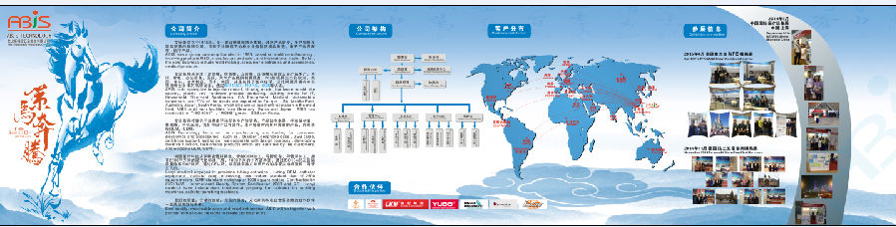
Certification
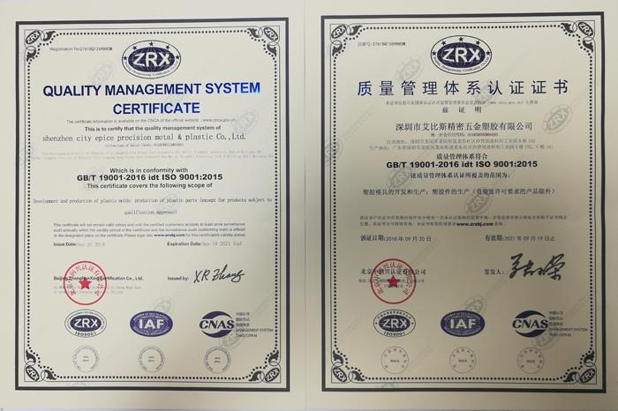

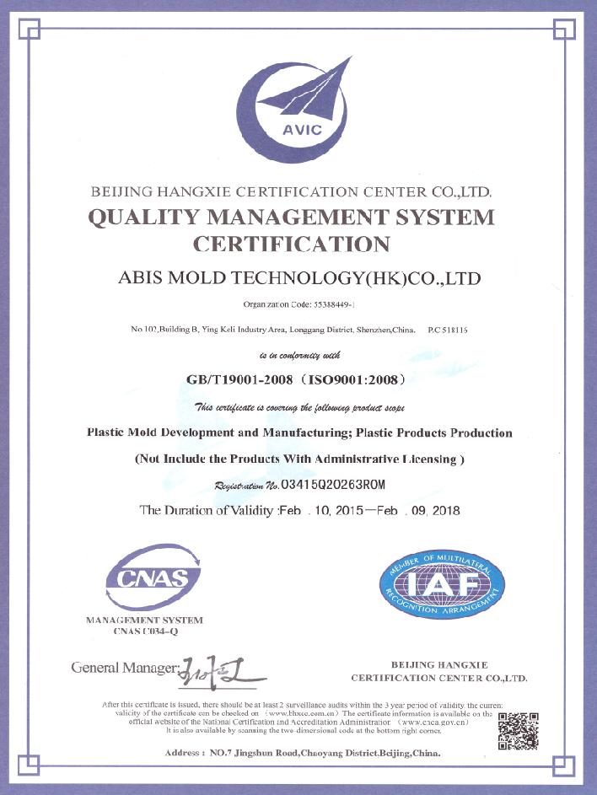 | 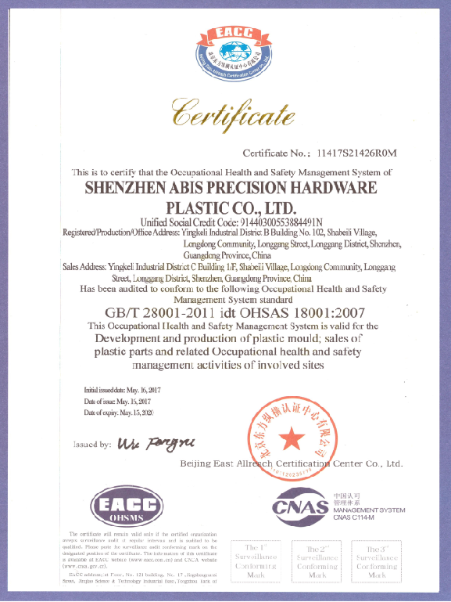
Tooling Shop

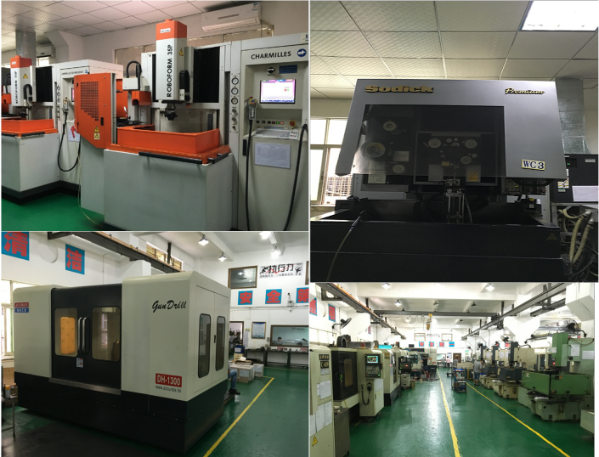
QC Control
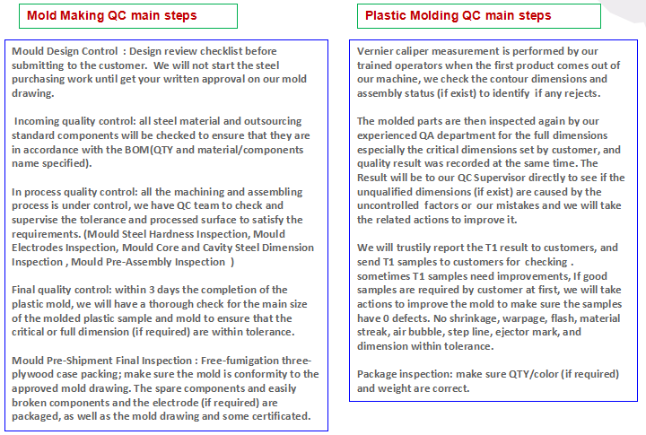
Packaging & Delivery
Packaging Details：Free-Fumigation Three-Plywood case
Delivery Detail: 25-35 days by sea, 3-7 days by air

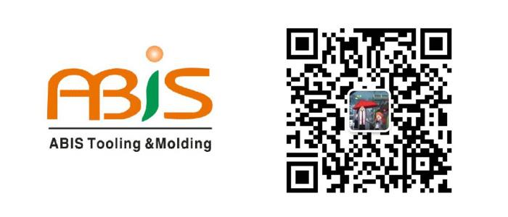

ABIS MOLD TECHNOLOGY CO.,LTD
Daisy Wang (Overseas sales)
Web: www.abismold.com
Cell/whatsapp: +86-15016526799
Skype: daisymold@outlook.com
Email: Daisy@abismold.com
Add: Building B#,YingKeli Industrial Part, LongDong Community,
LongGang District, Shenzhen, China 518116

FAQ

Q: What can we do if we don't have the mold drawing?
A: you will only provide the actual sample to us then we can help you to make the design injection mold drawings for your confirmation.

Q: Can we test the plastic injection mold?
A: After the mold is ok ,we can help you to test the mold for free.

Q: What can you do for you?
A: Make optimum solution to reduce your cost
B: Product your idea and design to products
C: Quality inspection and inspection report
D: Professional export service

Q: Before shipment, how to make sure the products quality?
A: If you don't come to our factory and also don't have the third party for inspection, we will be as your
inspection worker. We will supply you a video for production process detail include process report,
products size, structure and surface detail, packing detail and so on.

Q: Can you do post production?
A: Some customers in addition to plastic injection require post processing, assembly of their products
and packaging.

Q: Is it possible to know how are my products going on without visiting your company?
A: We will offer a detailed production schedule and send weekly reports with digital pictures and videos
which show the machining progress.

